Activity 6 - Overlapping

Can you answer the following?

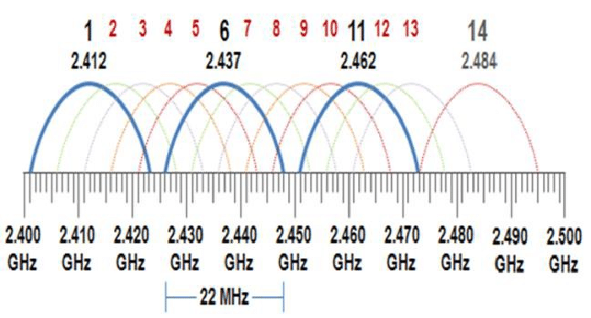
1. What channels does channel 3 overlap with?
1,2,4,5,6,
2. What channels does channel 8 overlap with?
4, 5, 6, 7, 9, 10, 11, 12

3. What channels does channel 14 overlap with?
12, 13

4. What channels does channel 11 overlap with?
7, 8, 9, 10, 12, 13

5. How many channels are covered by one channel?
4

6. What is the Ghz range for channel 11?
2.451 – 2.473 (0.022Ghz)

